Introduction to Data Manipulation in SAP Analytics Cloud

|  |  |
| --- | --- |
| Camera | **Anand Kumar Bhagat**  **L20604271** |

**Objective:**  
To identify the distribution channel with the highest sales by examining the Distribution Channel Details panel in SAP Analytics Cloud. The goal is to assess sales performance and evaluate the effectiveness of various channels in contributing to business growth.

**Analysis:**  
The Distribution Channel Details panel revealed that **Convenience Store** recorded the highest sales. This channel's superior performance highlights its key role in driving revenue, demonstrating effective sales strategies and market reach.

Step 1:

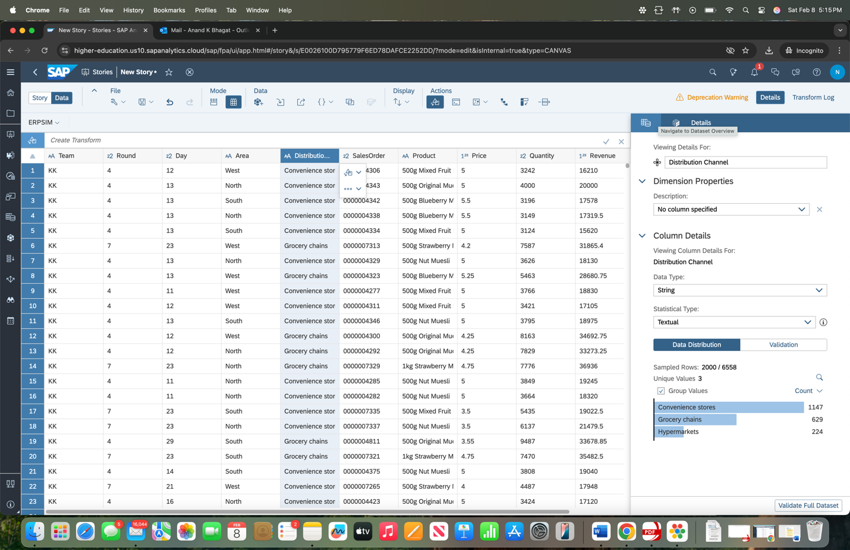

### **Highest Revenue from Muesli Sales**

**Objective:**  
To determine which combination of entities generated the highest revenue from the sales of Muesli products. This involves analyzing sales data from multiple entities to identify the top-performing combination in terms of revenue.

**Analysis:**  
The combination of **North Hypermarkets** recorded the highest revenue from Muesli sales. This entity's performance surpassed others, indicating its significant contribution to overall revenue from Muesli products.

Step 2:

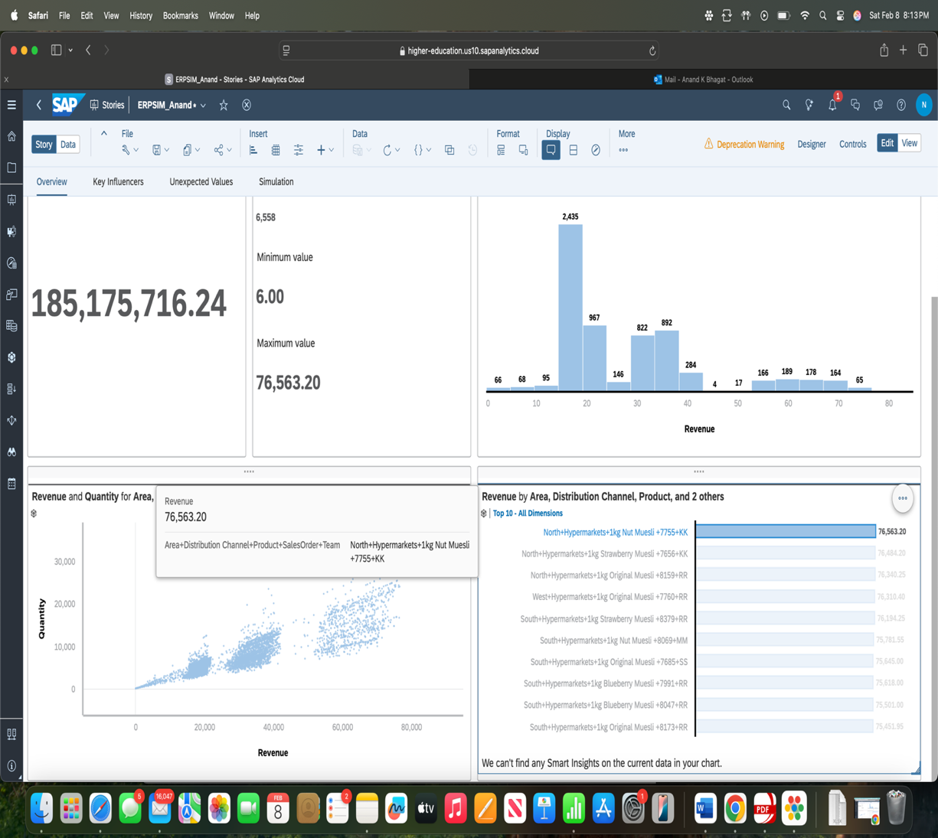

**Highest Sale**

**Objective:**  
To identify the highest sale in the dataset by looking for the maximum sale value. This involves examining the sales data to determine the top individual sale.

**Analysis:**  
The highest sale recorded was from the **Convenience Store**. This sale represents the peak transaction in the dataset, showcasing the largest single sale and providing valuable insight into peak business performance

*Step: 3*

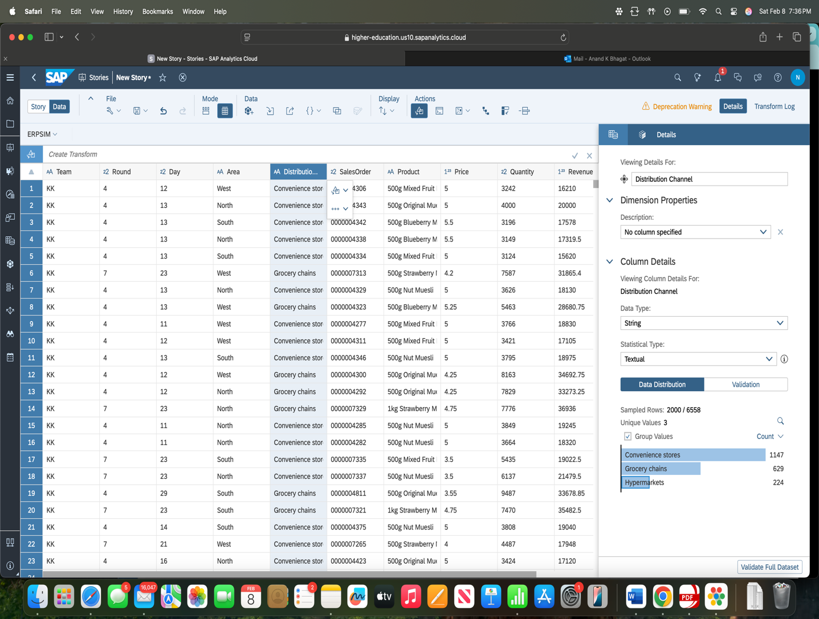

**Objective:**  
To identify the key factors influencing revenue by analyzing the Key Influencers feature in SAP Analytics Cloud. This involves examining how different variables affect revenue generation.

Step 4: Key Influencers of Revenue

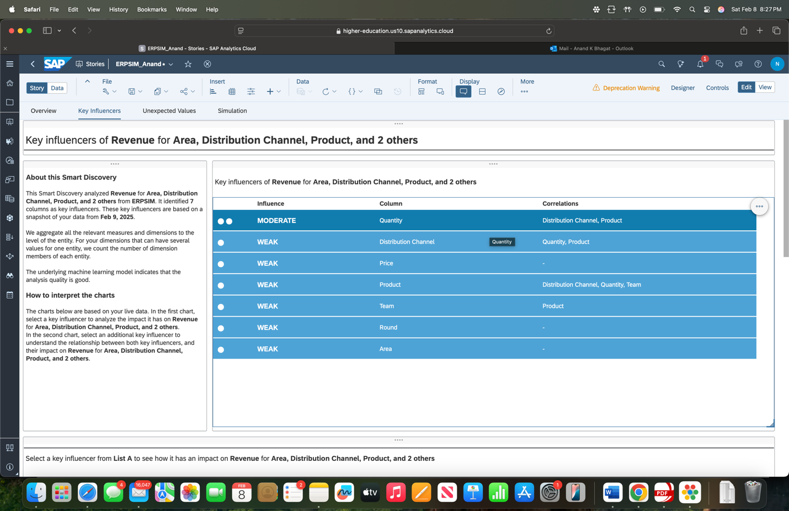

### ***Most Commonly Occurring Revenue and Price Bin***

**Objective:**  
To identify the most commonly occurring Revenue and Price bins by analyzing the frequency of occurrences within specific ranges. This involves examining the histogram to determine the bins with the highest frequencies.

**Analysis:**  
The most commonly occurring **Revenue bin** is from the **Area Distribution Channel**, and the most commonly occurring **Price bin** is from the **Product** category. These bins represent the ranges with the highest frequency of occurrences, offering valuable insights into the distribution of revenue and pricing.

Step 5:

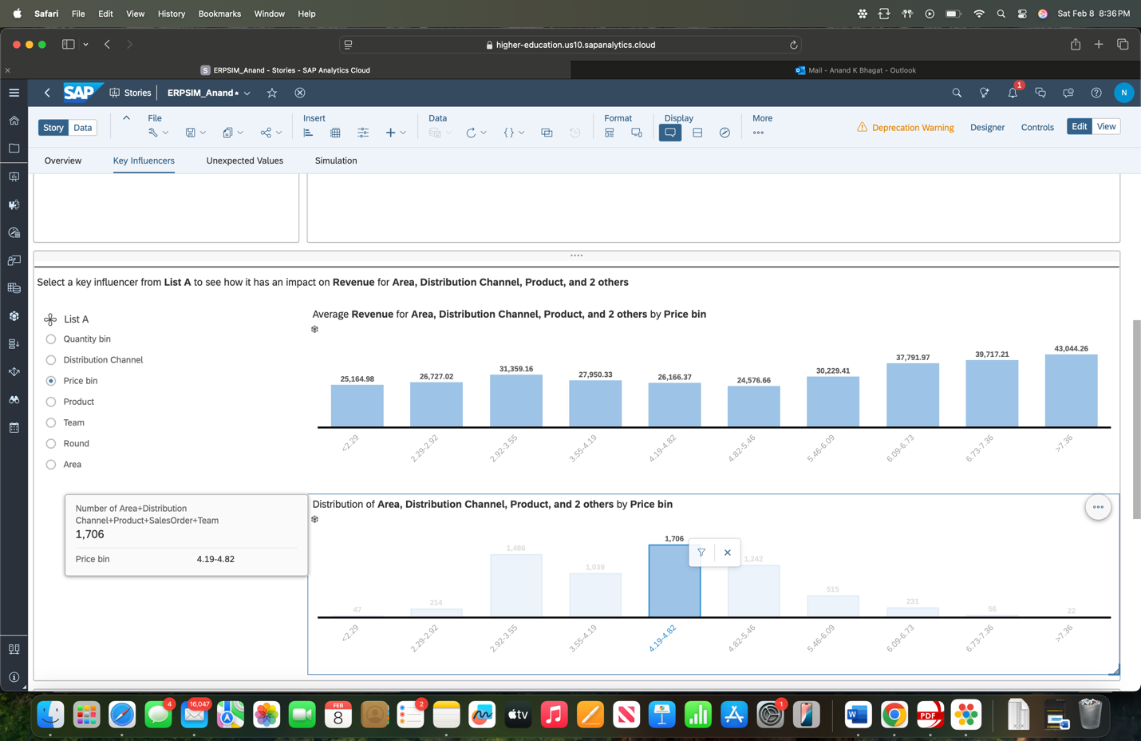

**Objective:**  
To identify which price bin has the greatest impact on average revenue. This involves examining the relationship between price ranges and average revenue, using the data to determine which bin most influences revenue.

Step 6: Price Bin Impact on Average Revenue

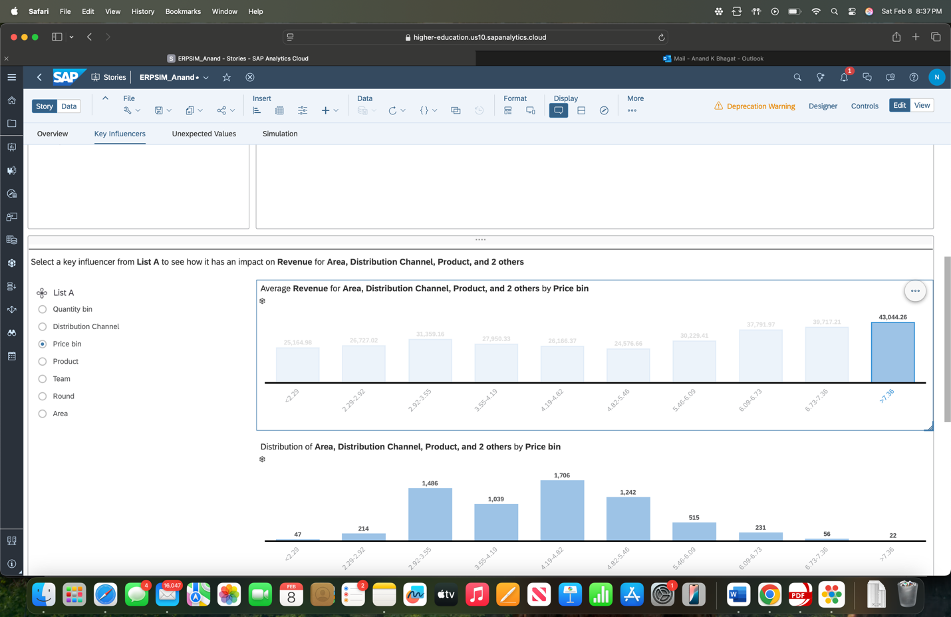

**Objective:**  
To identify which distribution channel has the highest average revenue. This involves analyzing the revenue data across different channels to determine the one that contributes the most in terms of average revenue.

Step 7: Distribution Channel with Highest Average Revenue

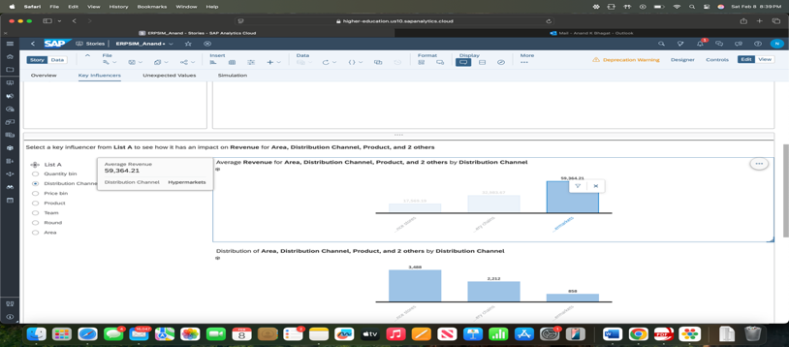

**Objective:**  
To capture the initial values displayed on the simulation page before any changes are made.

**Analysis:**  
The initial values for the simulation are shown on the Simulation Page, serving as the baseline for future analysis and adjustments.

Step 8: Initial Values for the Simulation

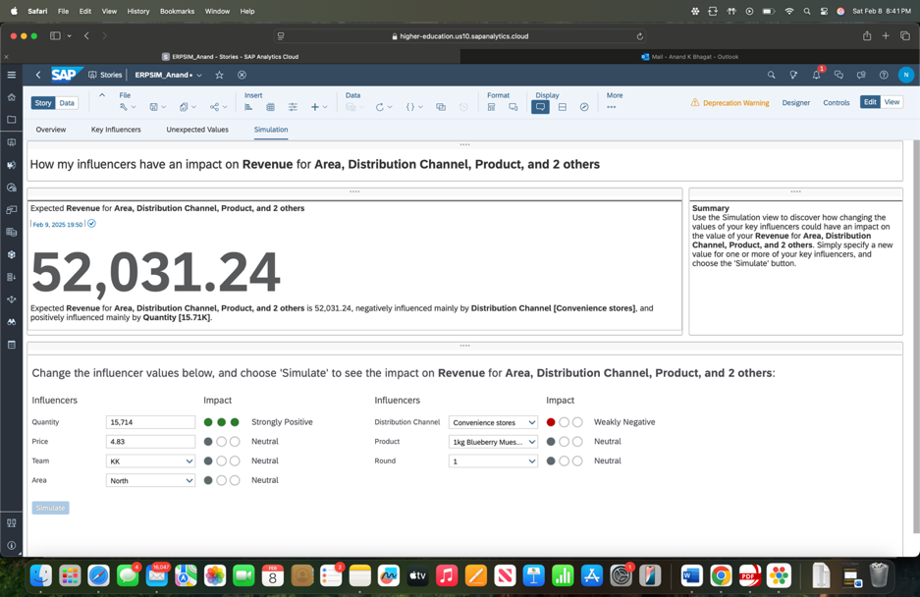

### **Team with the Highest Total Revenue**

**Objective:**  
To identify the team with the highest total revenue and report the revenue amount. This involves reviewing the data to find the team that contributed the most to total revenue.

**Analysis:**  
The team with the highest total revenue is **RR**, with a total revenue of **32,297,798**. This team outperformed all others, contributing significantly to the overall financial results.

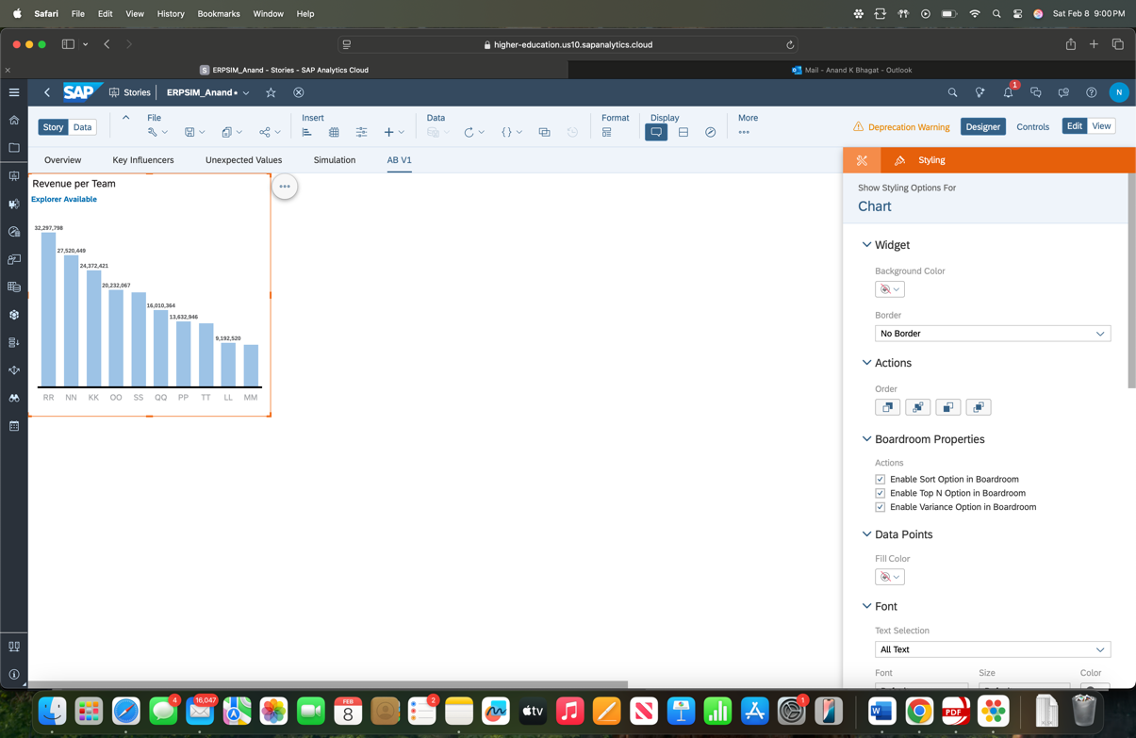

### **Product with the Highest Total Revenue**

**Objective:**  
To determine which product had the highest total revenue and report the revenue value. This involves analyzing the data to identify the top-performing product in terms of revenue.

**Analysis:**  
The product with the highest total revenue is **500g Nut Muesli**, with a revenue of **24,445,957**. This product generated the most revenue, highlighting its popularity and strong market performance.

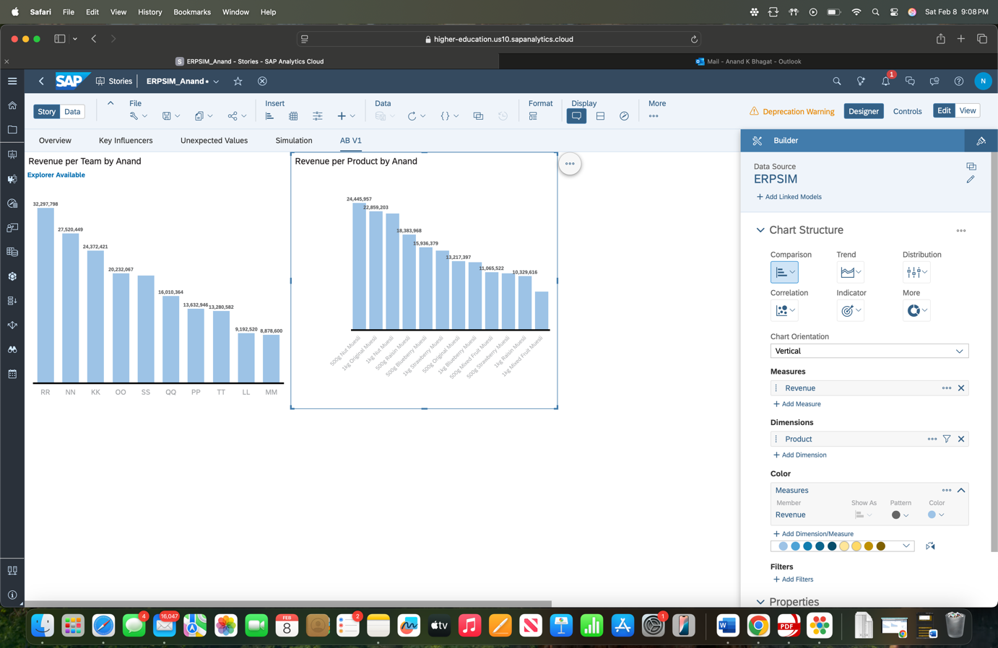

Step 11: Trend of Revenue over Rounds for each Team.

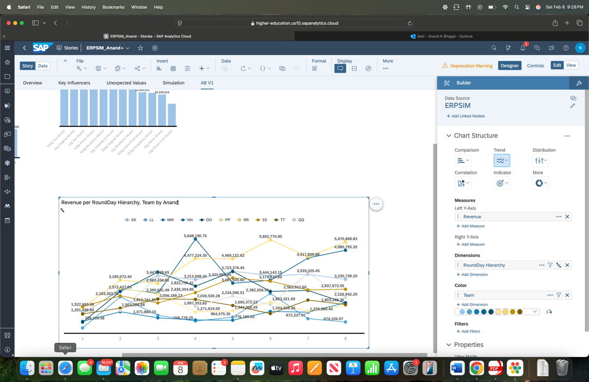

Step 12: Market share of each Team by Product

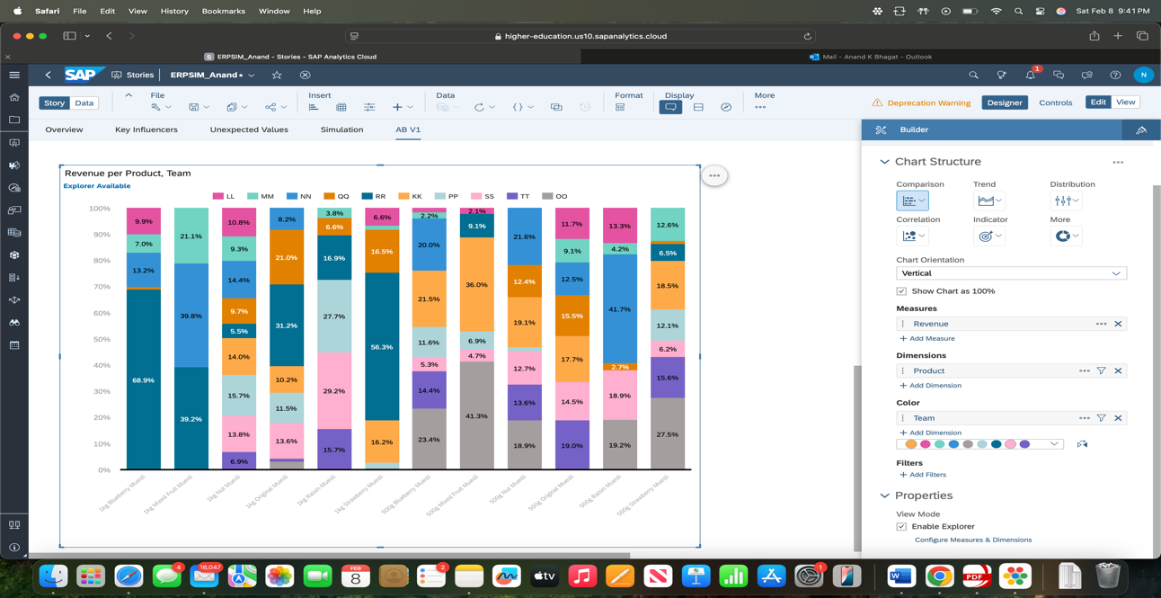

**Products Not Sold in Specific Distribution Channels**

**Objective:**  
To identify any products that are not sold in specific distribution channels. This involves examining the sales data to find products that are absent from certain channels.

**Analysis:**

* **Products not sold in Hypermarkets**:
  + 500g Blueberry Muesli
  + 500g Mixed Fruit Muesli
  + 500g Null Muesli
  + 500g Original Muesli
  + 500g Raisin Muesli
  + 500g Strawberry Muesli
* **Products not sold in Convenience Stores**:
  + 1kg Blueberry Muesli
  + 1kg Mixed Fruit Muesli
  + 1kg Nut Muesli
  + 1kg Original Muesli
  + 1kg Raisin Muesli
  + 1kg Strawberry Muesli

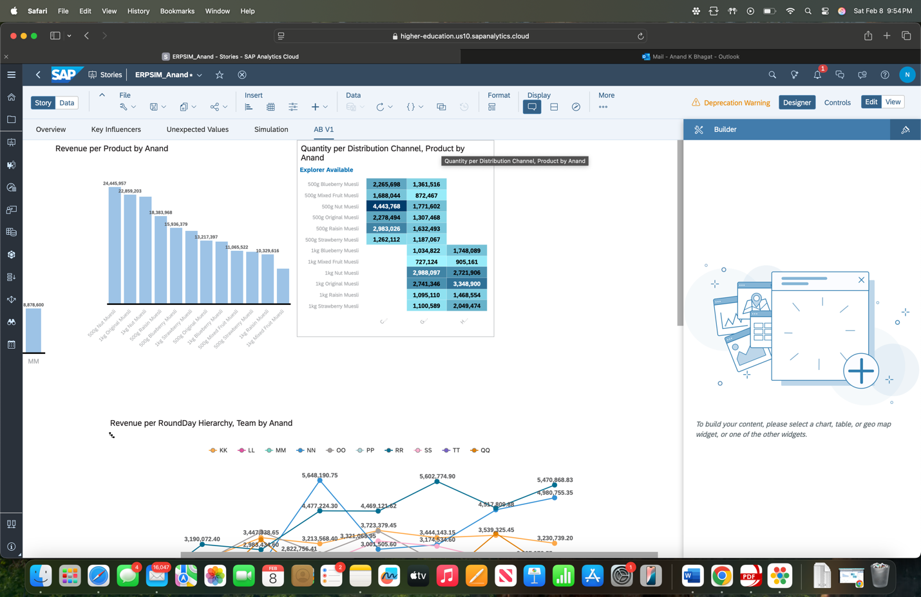

### **Highest Priced Muesli on Day 18 of Round 1**

**Objective:**  
To identify the highest-priced muesli on Day 18 of Round 1 and determine which team sold it, along with the price.

**Analysis:**  
The highest-priced muesli on Day 18 of Round 1 was **1 kg Raisin Muesli**. It was sold by the **PP team**, and the price was **7**

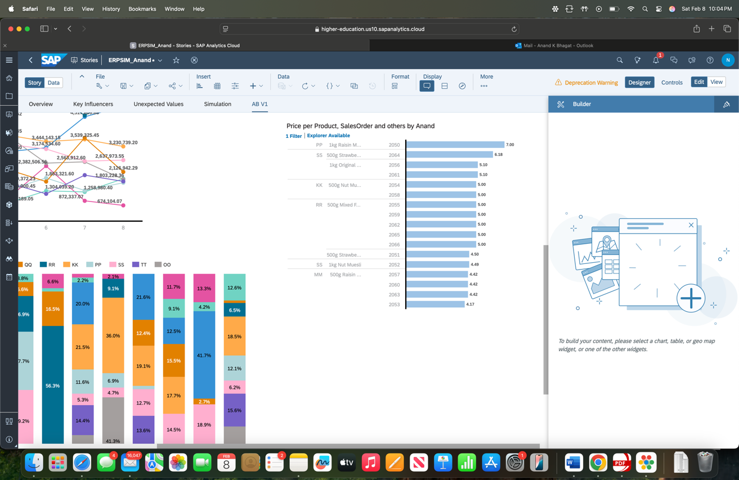

### **Team with Highest Quantity of Muesli Sold**

**Objective:**  
To identify the team that sold the highest quantity of muesli and the most sold product for that team.

**Analysis:**  
The **RR Team** sold the highest quantity of muesli. The most sold product for the RR team was **1 kg Original Muesli**, with a total of **2,066,277 units sold**.

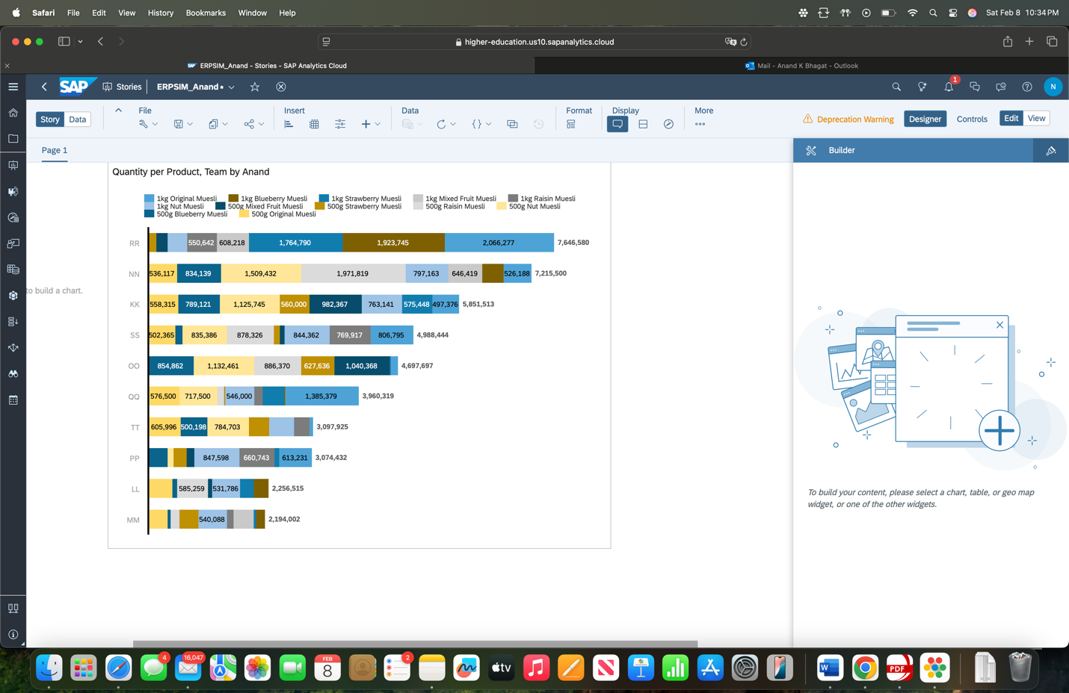

### **Days with No Revenue for Individual Teams**

**Objective:**  
To identify the days on which individual teams did not generate any revenue. This involves analyzing the sales data to find out when each team had zero revenue

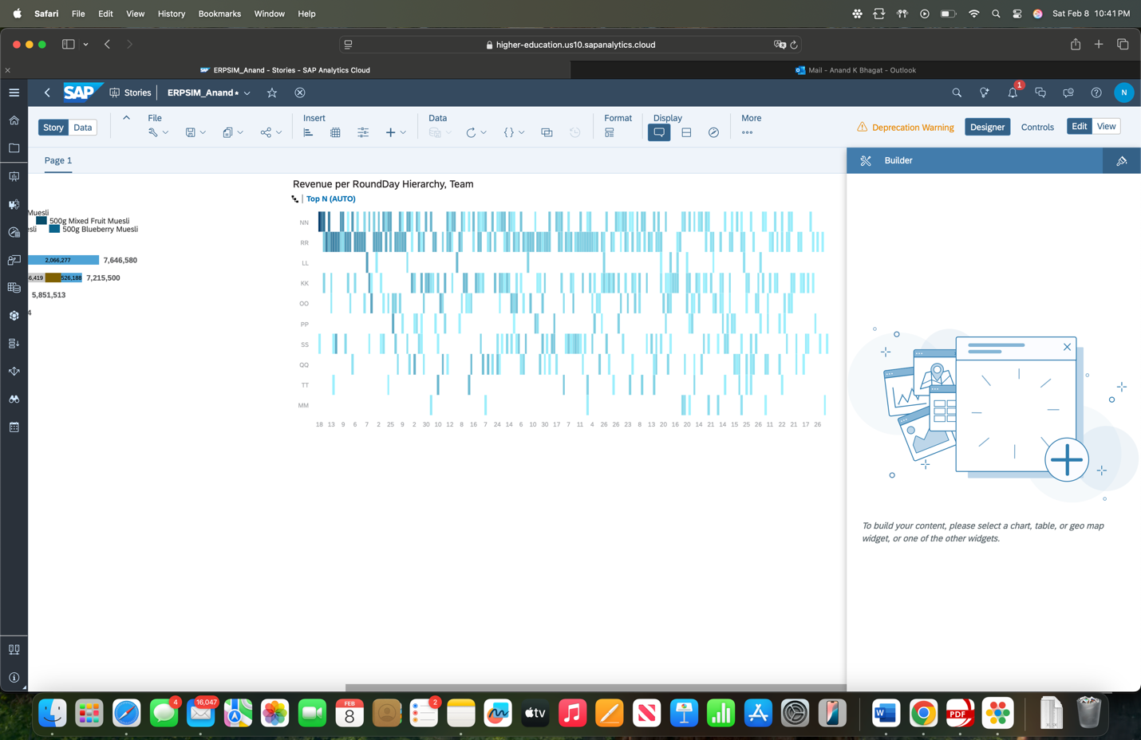

### **Product, Day, and Round with Highest Revenue**

**Objective:**  
To identify the product, day, and round that generated the highest revenue, as well as the team responsible for that revenue.

Answer: 1 Kg nut muesli has the highest revenue

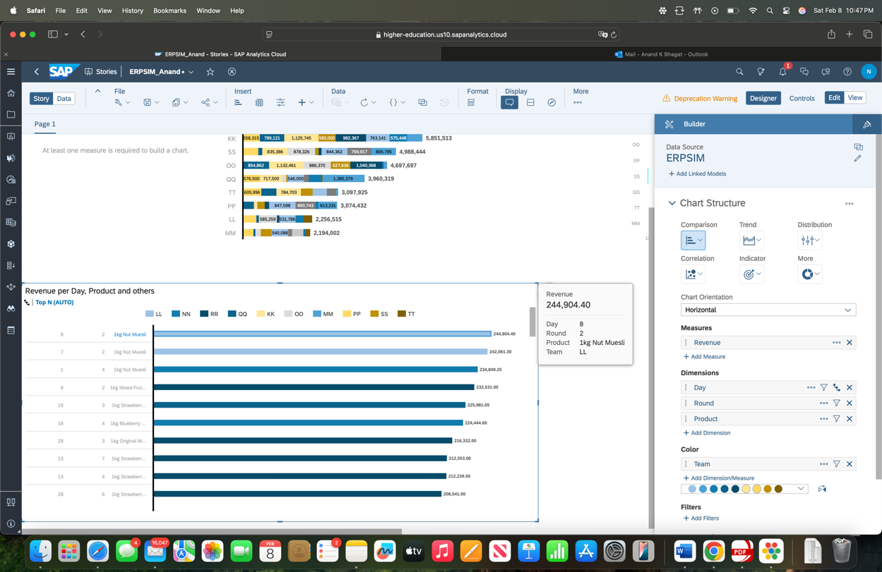

### **Benford’s Law Analysis Using SAP Predictive Analytics**

**Objective:**  
To conduct a Benford’s Law analysis using SAP Predictive Analytics on a sales dataset and evaluate the distribution of leading digits in the data.

**Analysis:**

* The dataset contains **171,010 rows** and **25 columns**.
* The **sample size** used for analysis is **2,000 rows**.

This analysis helps in identifying anomalies by comparing the distribution of the leading digits with the expected frequencies according to Benford's Law.

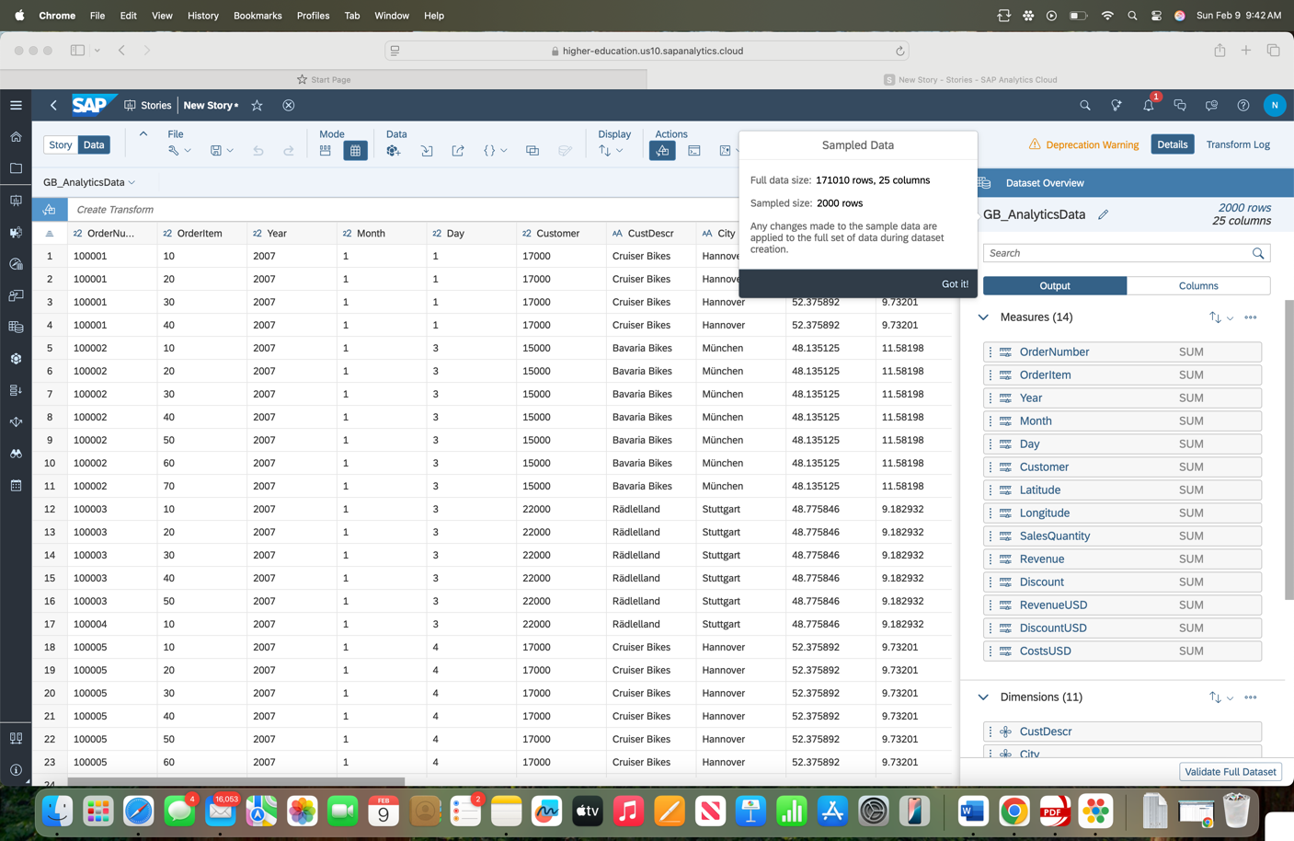

**Objective:**  
To create and capture a column chart based on the data from the Benford’s Law analysis, ensuring that your name is included in the chart title.

**Analysis:**  
A column chart was generated to visualize the frequency of leading digits in the dataset, based on Benford’s Law. The chart clearly shows the distribution and any deviations from the expected pattern.

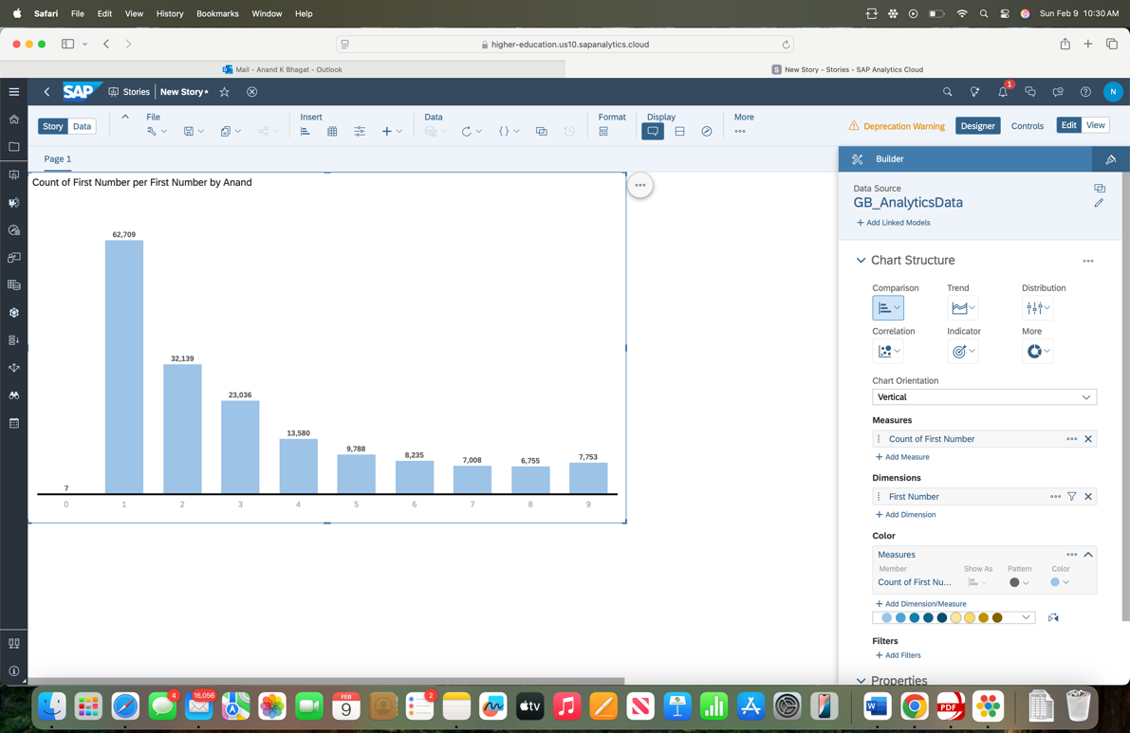

**Objective:**  
To generate and capture another column chart based on the Benford’s Law analysis, ensuring that your name is included in the chart title.

**Analysis:**  
This column chart visualizes the distribution of the first digits in the dataset to check for compliance with Benford’s Law.

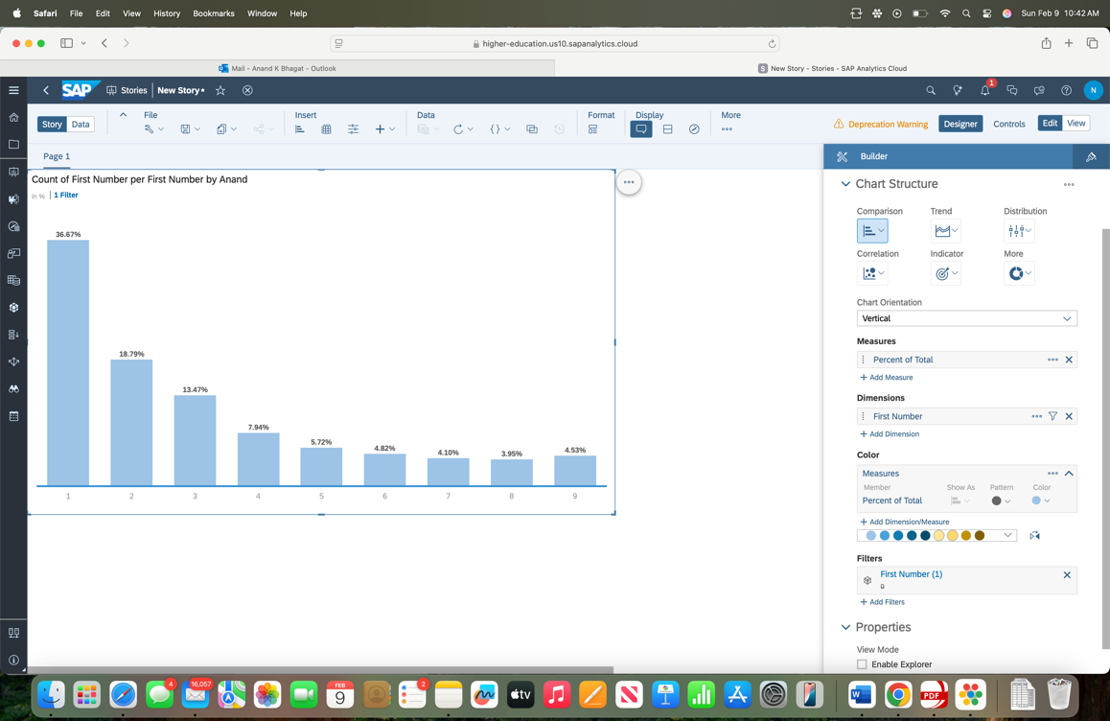

**Objective:**  
To capture and display the linked dimensions used in the Benford’s Law analysis in SAP Predictive Analytics.

**Analysis:**  
The linked dimensions represent the various attributes or categorical variables associated with the data. These dimensions are linked to the data for a more granular analysis, helping to assess the consistency and validity of the dataset based on Benford’s Law.

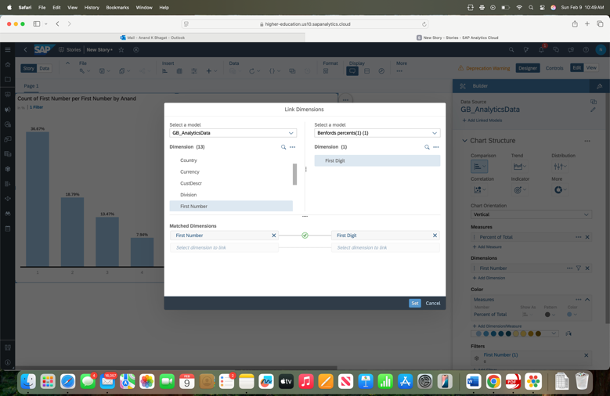

**Objective:**  
To generate and capture the final chart after completing the Benford’s Law analysis, ensuring that your name is included in the chart title.

**Analysis:**  
The final chart summarizes the findings from the Benford’s Law analysis. It shows the distribution of leading digits in comparison with the expected frequencies, highlighting any anomalies

